

**EC 603: Digital Communication Laboratory Project**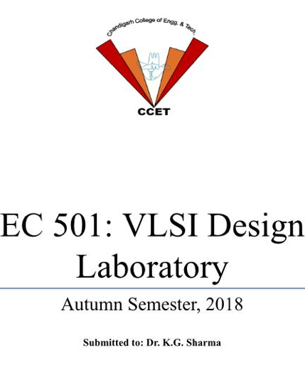

**Branch/Sem: ECE/6th**

**Submitted By: Lokesh Kumar (Roll No: CO16526)**

**Moksh Bansal (Roll No: CO16531)**

**PROJECT :**

**Gesture Controlled Computer**

**🡪Components Required**

* Arduino UNO x 1
* Ultrasonic Sensors x 1
* USB Cable (for Arduino)
* Few Connecting Wires
* A Laptop with internet connection

🡪**Description:**

The concept behind the project is very simple. We will place an Ultrasonic (US) sensor on top/side of our monitor and will read the distance between the monitor and our hand using Arduino, based on this value of distance we will perform certain actions. To perform actions on our computer we use Python **pyautogui** library. The commands from Arduino are sent to the computer through serial port (USB). This data will be then read by python which is running on the computer and based on the read data an action will be performed.

**Circuit Diagram:**

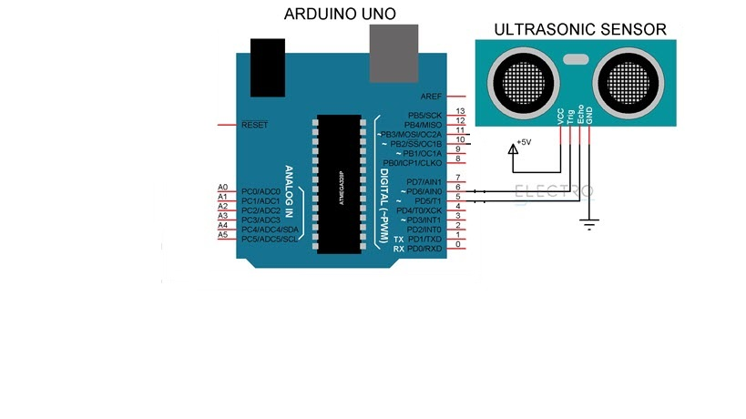

**🡪Program Code:**

**Arduino Programming**

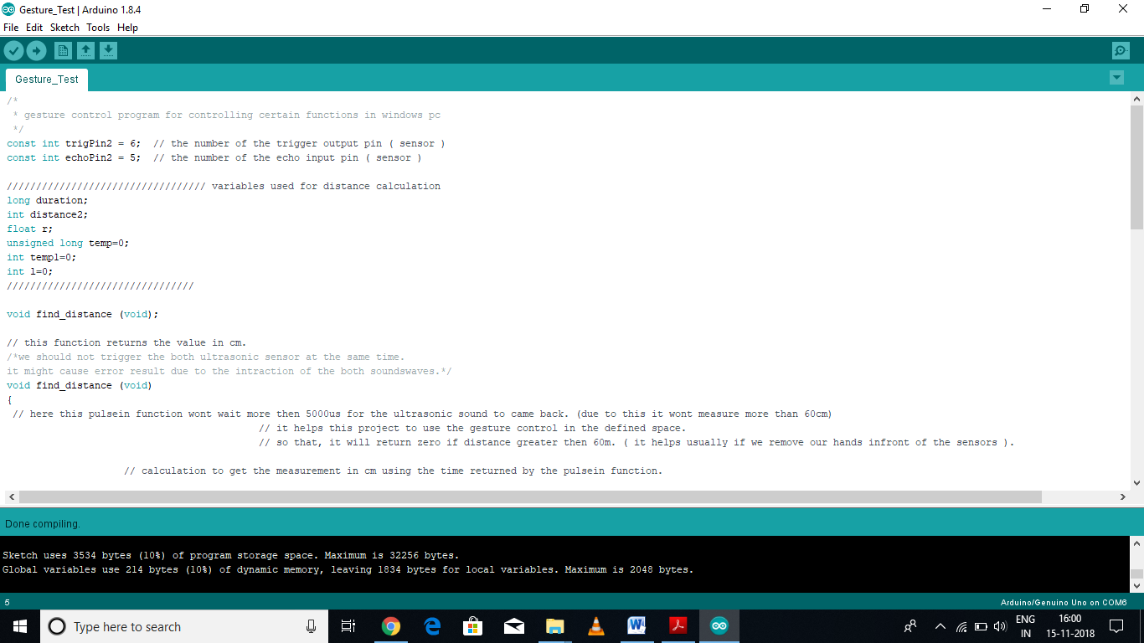

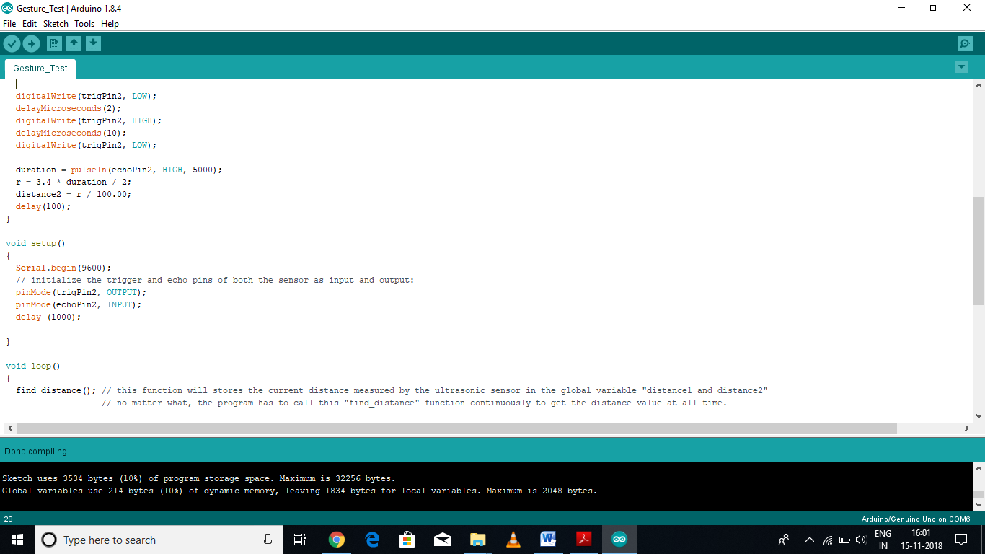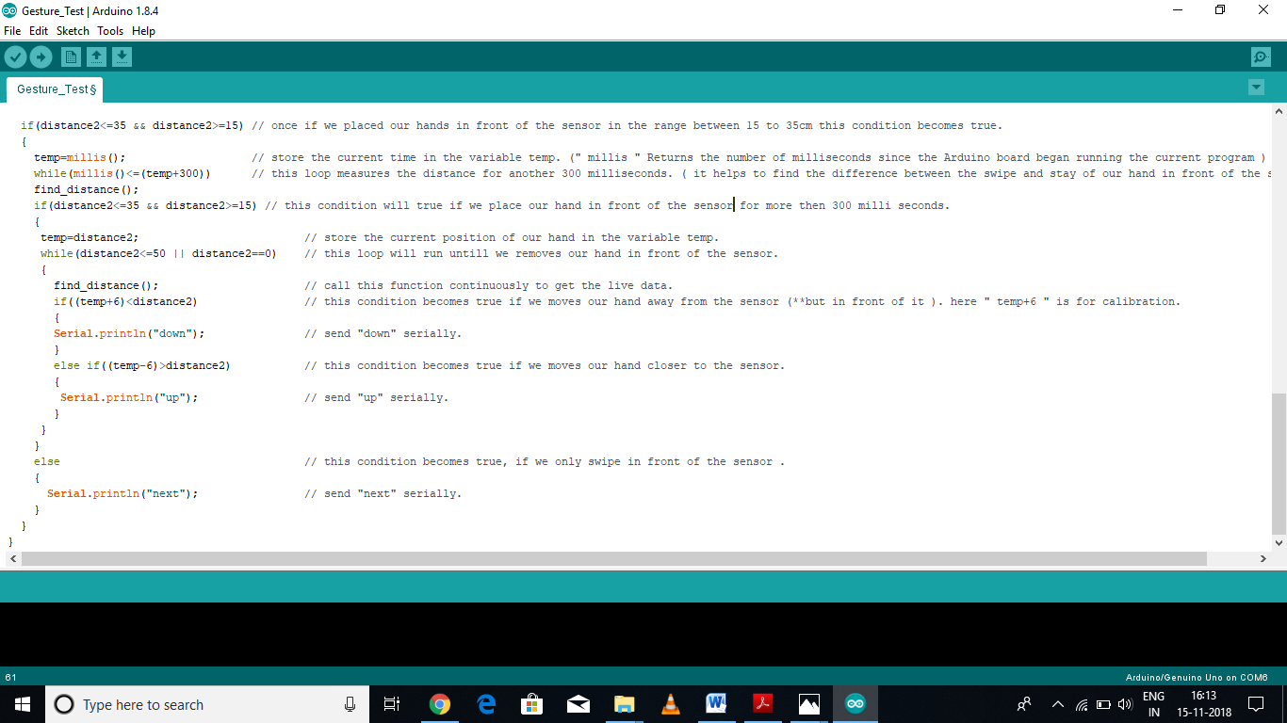

**Python Programming**

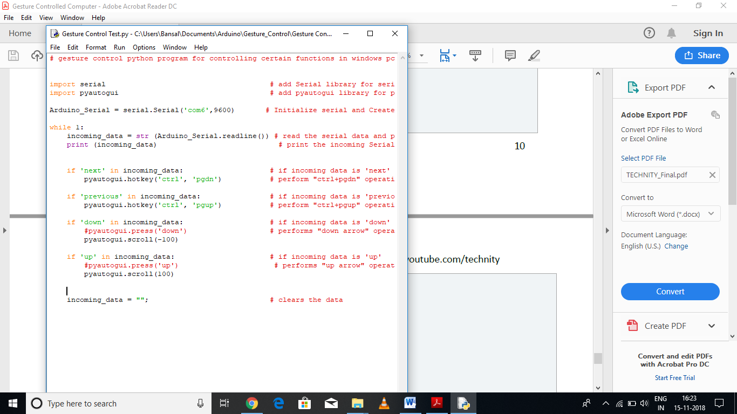

**Snapshot Of Project**

